**Hypothesis Testing**

**Introduction:**

A Hypothesis test is a statistical test that is used to determine whether there is enough evidence in a sample of data to infer that a certain condition is true for the entire population.

When your car breakdown you will make an educated guess that there may be not enough petrol or may be some technical problem. Then you will take car to the nearest workshop to validate your guess/assumption/hypothesis. Depend on Mechanic answer you will reject one hypothesis and accept another hypothesis.

Here Null hypothesis is “not enough petrol”; Alternate hypothesis is may be some technical problem.

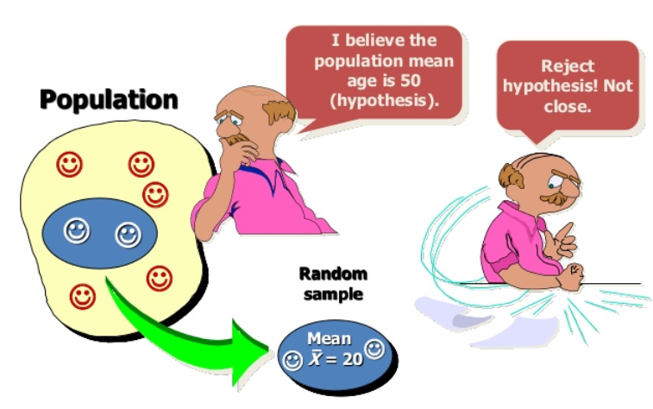

A hypothesis test examines two opposing hypotheses about a population: the null hypothesis and the alternative hypothesis.

Null hypothesis (H0):

The null hypothesis states that a population parameter is equal to a value. The null hypothesis is often an initial claim that researchers specify using previous research or knowledge.

Alternative Hypothesis (H1):

The alternative hypothesis states that the population parameter is different than the value of the population parameter in the null hypothesis. The alternative hypothesis is what you might believe to be true or hope to prove true.

Based on the sample data, the test determines whether to reject the null hypothesis. You use a p-value, to make the determination. If the p-value is less than or equal to the level of significance, which is a cut-off point that you define, and then you can reject the null hypothesis.

A common misconception is that statistical hypothesis tests are designed to select the more likely of two hypotheses. Instead, a test will remain with the null hypothesis until there is enough evidence (data) to support the alternative hypothesis.

Examples of questions you can answer with a hypothesis test:

* Does the mean height of undergraduate women differ from 66 inches?
* Is the standard deviation of their height equal less than 5 inches?
* Do male and female undergraduates differ in height?

**Simple Example to understand hypothesis testing:**

You can follow six basic steps to correctly set up and perform a hypothesis test. For example, the manager of a pipe manufacturing facility must ensure that the diameters of its pipes equal 5cm. The manager follows the basic steps for doing a hypothesis test.

1. Specify the hypotheses.

First, the manager formulates the hypotheses. The null hypothesis is: The population mean of all the pipes is equal to 5 cm. formally, this is written as: H0: μ = 5

Then, the manager chooses from the following alternative hypotheses:

| Condition to test | Alternative Hypothesis |
| --- | --- |
| The population mean is less than the target. | one sided: μ < 5 |
| The population mean is greater than the target. | one sided: μ > 5 |
| The population mean differs from the target. | two sided: μ ≠ 5 |

Because they need to ensure that the pipes are not larger or smaller than 5 cm, the manager chooses the two-sided alternative hypothesis, which states that the population mean of all the pipes is not equal to 5 cm. formally, this is written as H1: μ ≠ 5

1. Determine the power and sample size for the test.

The manager uses a power and sample size calculation to determine how many pipes they need to measure to have a good chance of detecting a difference of 0.1 cm or more from the target diameter.

1. Choose a significance level (also called alpha or α).

The manager selects a significance level 0.05, which is the most commonly used significance level.

1. Collect the data.

They collect a sample of pipes and measure their diameters.

1. Compare the p-value from the test to the significance level.

After they perform the hypothesis test, the manager obtains a p-value of 0.004. The p-value is less than the significance level of 0.05.

1. Decide whether to reject or fail to reject the null hypothesis.

The manager rejects the null hypothesis and concludes that the mean pipe diameter of all pipes is not equal to 5cm.

**Test to validate hypothesis:**

1. ANNOVA
2. Chi-square
3. T-Test
4. F-Test
5. A/B testing

Hypothesis tests can be used to evaluate many different parameters of a population. Each test is designed to evaluate a parameter associated with a certain type of data. Knowing the difference between the types of data, and which parameters are associated with each data type, can help you choose the most appropriate test.

**Interview Question:**

1. Explain the reasons why you apply to "Hypothesis Testing"
2. What does P-value signify about the statistical data
3. Can we change p-value threshold?
4. What is the goal of A/B Testing